***Relation between the lattice constant and the density of crystal material:***

Let us consider a unit cell with volume *V* (cm3), which can be calculated from the unit cell dimensions. Let ** (gm/cm3) be the density of the crystal. Then the weight of the matter in the unit cell will be $V×ρ$.

If *n* is the number of atoms or molecules per unit cell and *M* being the atomic (molecular) weight of one atom or molecule. Then the weight of matter in the unit cell is given by $n\frac{M}{N}$.

Thus $n\frac{M}{N}=V×ρ$

$$∴ n=\frac{V×ρ×N}{M}$$

For a cubic crystal, $V=a^{3}$. Thus

$$n=\frac{a^{3}×ρ×N}{M}$$

$$∴ a^{3}ρ=n\frac{M}{N}$$

***Mathematical Problems***

***Problem-1:*** *The atomic weight of silver is 108. It has lattice constant 4.077 A0. Calculate the density of silver if it has the fcc structure.*

***Solution:*** We know

Here,

$$n=4$$

$$M=108 gm$$

$$N=6.023×{10}^{23}$$

$$a=4.077×{10}^{-8}cm$$

$$ρ= ?$$

$$ρ=\frac{nM}{a^{3}N}$$

$$Or ρ=\frac{4×108}{{\left(4.077×{10}^{-8}\right)}^{3}×6.023×{10}^{23}}$$

$$∴ ρ=10.58 gm/{cm}^{3} (Ans)$$

***Problem-2:*** *Calculate the number of atoms per unit cell for a face centered cubic (fcc) lattice of copper crystal. Given a= 3.60 A0, Atomic weight of copper = 63.6 and density of copper = 8.86.*

***Solution:*** We know

Here,

$$a=3.60×{10}^{-8}cm$$

$$M=63.6 gm$$

$$ρ= 8.86 gm/{cm}^{3}$$

$$N=6.023×{10}^{23}$$

$$n= ?$$

$$n=\frac{a^{3}Nρ}{M}$$

$$Or n=\frac{{\left(3.60×{10}^{-8}\right)}^{3}×6.023×{10}^{23}×8.86}{63.6}$$

$$∴ n=3.96≅4 (Ans)$$

***Problem-3:*** *NaCl has fcc structure. The density of sodium chloride is 2180 kg/m3. Calculate the distance between two adjacent atoms. Given the atomic weight of sodium=23 and the Chlorine=35.5. Take $N=6.02×{10}^{23}per kg-mole.$*

***Solution:*** We know

Here,

$$n=4$$

$$ρ= 2180 kg/m^{3}$$

$M=\left(23+35.5\right) gm=58.5 gm$

$$=58.5×{10}^{-3} kg$$

$$N=6.023×{10}^{23}$$

$$d=?$$

$$a^{3}=\frac{nM}{ ρN}$$

$$Or a={\left(\frac{4×58.5×{10}^{-3}}{2180×6.023×{10}^{23}}\right)}^{1/3}$$

$$∴ a=5.63×{10}^{-10} cm$$

Distance between the adjacent atoms

$$d=\frac{a}{2}=\frac{5.63×{10}^{-10}}{2}=2.815×{10}^{-10} cm=2.815 A^{0} (Ans)$$

***Problem-4:***Iron has bcc structure. Its density is $7.86 gm/{cm}^{3}$ and. Atomic weight of Iron is 55.85. Calculate the dimension of the unit cell.

***Solution:*** Do yourself. (**Ans:** 2.87 *A0*)

***Unit face, Numerical Parameter & Axial units***

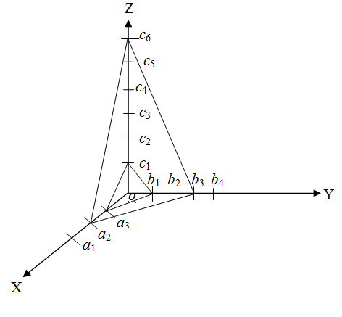

In fig. 1, let *OX*, *OY* and *OZ* be taken as the reference axes. The faces *a*3 *b*1 *c*1 and *a*2 *b*3 *c*6 make certain intercepts or segments on these axes. The first face or plane intercepts segments of *oa3*, *ob*1 and *oc*1 and the second – *oa*2, *ob*3 and *oc*6. These segments represent the respective *linear parameters* of the two *faces*.

It is seen that the first face intercepts one spacing along each axis whereas second face intercepts two, three and six spacing’s along the respective axes. The first face is called the *unit face* which may be defined as *the face which makes one intercepts on each axes.*

**Fig. 1**

Obviously, the unit face produces three values which are related to each other as 1 : 1 : 1. The second face produces three values 2*a*, 3*b*, 6*c* which are related to each other as 2 : 3 : 6. These figures of 1, 2, 3, and 6 represent *the numerical parameters* of the faces and must be whole numbers.

Linear parameters intercepted by the *unit face* are called the *axial units*. In the present case, these are *a*1*, b*1, and *c*1 although they are represented generally by *a, b*, and *c*along *X*, *Y,* and *Z* axes respectively.

***Miller indices***

*The position and orientation of a crystal plane is determined by three numbers (integers) is called Miller indices. It is denoted by (h k l).*

***Determination of Miller Indices:***

* Taking any atom in the crystal as the origin and erect coordinate axes from this atom.
* Taking intercepts on the axis *a, b, c* in terms of the lattice constants.
* Taking the reciprocal of these intercepts.
* Taking the lowest common multiple of the denominator.
* Multiplying each reciprocal by the lowest common multiple of the denominator, thus obtained into smallest set of integers. These integers are denoted by *h, k, l*.
* The result is conventionally enclosed in first parenthesis *(hkl)* which is Miller indices of the plane. The meaning of these indices is that a set of parallel planes (*hkl*) cuts the *a*-axis into *h* parts, the *b*-axis into *k* parts and the *c*-axis into *l* parts.

*While finding Miller Indices of a plane, following points should be kept in mind:*

* When the plane is parallel to one of the coordinate axes, it is said to meet that axis at infinity. Since $\frac{1}{∞}=0$, the miller index for that axis is zero.
* If a plane cuts on axis on the negative side of the origin, the corresponding index is negative and is indicated by a bar sign, above the index $(\overline{h}\overline{k}\overline{l})$.

***Example:*** The figure shows a plane whose intercepts are $1a, 2b, 3c$. The Miller indices of the family to which this plane belongs are obtaining by taking the reciprocals of these numbers: and reducing these factions to the smallest set of integers. This can be done by multiplying each of the fractions by the lowest common multiple of the denominator 6. In this case we get 6, 3, 2.

*Thus the Miller indices of this plane are (632)*

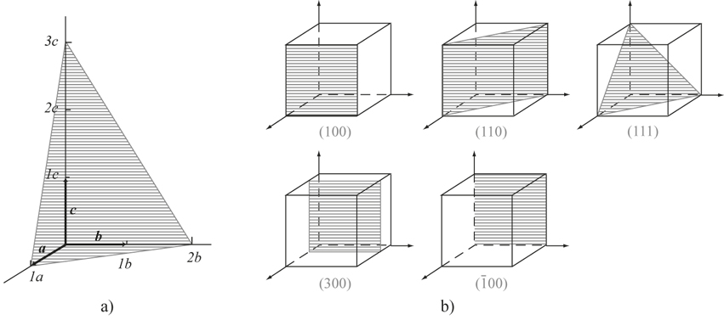

***Miller indices for planes in each of the following sets of intercepts:***

1. $a, 2b, ∞$ (ii) $a, \frac{b}{2}, c$ (iii) $3a,3b, 3c$

***Solution:*** (i) It indicates a plane whose intercepts are $a, 2b, ∞$. For *c*-axis the intercept is at $∞$. The Miller indices of the family to which this plane belongs are obtaining by taking the reciprocals of these numbers: $1$, $\frac{1}{2}$, $\frac{1}{∞}$. From this we can write: $1$, $\frac{1}{2}$, $0$. For reducing these factions to the smallest set of integers, multiply each of the fractions by the lowest common multiple of the denominator 2. In this case we get the Miller indices $\left(2, 1, 0\right)$.

(ii) It indicates a plane whose intercepts are $a, \frac{b}{2}, c$. The Miller indices of the family to which this plane belongs are obtaining by taking the reciprocals of these numbers:,, and reducing these factions to the smallest set of integers. This can be done by multiplying each of the fractions by the lowest common multiple of the denominator 1. In this case we get the Miller indices $\left(1, 2, 1\right)$.

(iii) It indicates a plane whose intercepts are $3a,3b, 3c$. The Miller indices of the family to which this plane belongs are obtaining by taking the reciprocals of these numbers: , , and reducing these factions to the smallest set of integers. This can be done by multiplying each of the fractions by the lowest common multiple of the denominator 3. In this case we get the Miller indices $\left(1, 1, 1\right)$.

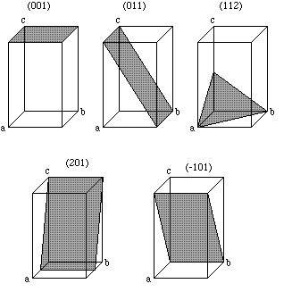***Drawing planes from Miller indices:***

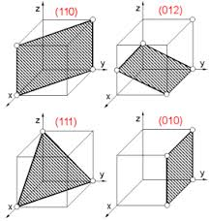







***Direction of plane:*** Any vector drawn from the origin to a lattice point is defined as direction. It is denoted by *[hkl]*. For example, in a cubic unit cell, if the origin is at the one corner and axes are parallel to the edges, the body diagonal would be represented as [111].

***[hkl]*:** The direction specified by this symbol is obtained as follows: Move from the origin over a distance *ha* along the *a*-axis, *kb* along the *b*-axis and *lc* along the *c*-axis. The vector connecting the origin with the point so obtained is then the direction specified by the symbol *[hkl]*. Thus in a cubic crystal, the direction of the X-axis is indicated by [100], the Y-axis by [010] and the Z-axis by [001]. Similarly, the direction of the negative X-axis is indicated by $[\overline{1}00]$, the negative Y-axis by $[0\overline{1}0]$ and the negative Z-axis by $[00\overline{1}]$.

***In cubic crystal [hkl] direction is normal to the (hkl) plane:***

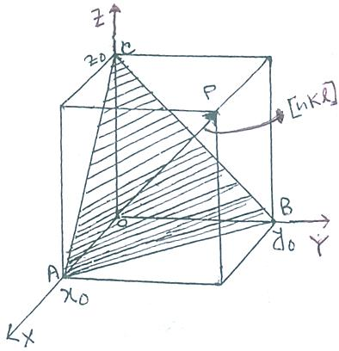

Let OP be the direction of $[hkl]$ and ABC be the $(hkl)$ plane. Again, let $x_{0}$, $y_{0}$ and $z_{0}$ are the intercepts of the plane (hkl) along X, Y and Z directions.

Miller indices are $\frac{1}{x_{0}},\frac{1}{y_{0}},\frac{1}{z_{0}}$.

and the reduced indices becomes $\frac{g}{x_{0}},\frac{g}{y_{0}},\frac{g}{z_{0}}$

Where $g$ is an integer.

For cubic lattice $h=k=l=1$.

$Or x_{0}=y_{0}=z_{0}=α$.

And the direction $\vec{OP}=\left(\hat{i}\frac{g}{α}+\hat{j}\frac{g}{α}+\hat{k}\frac{g}{α}\right)$

$$But \vec{AB}=\vec{OB}-\vec{OA}=\hat{j}\frac{g}{α}-\hat{i}\frac{g}{α}$$

$$Now \vec{OP}.\vec{AB}=\left(\hat{i}\frac{g}{α}+\hat{j}\frac{g}{α}+\hat{k}\frac{g}{α}\right).\left(\hat{j}\frac{g}{α}-\hat{i}\frac{g}{α}\right)=-\frac{g^{2}}{α^{2}}+\frac{g^{2}}{α^{2}}=0$$

Similarly we can write $\vec{OP}.\vec{BC}=0, \vec{OP}.\vec{CA}=0$.

Hence the dot product of $\vec{OP}$ with $\vec{AB}$, $\vec{BC}$ and $\vec{CA}$ is zero. So, $\vec{OP}$ is normal to $\vec{AB}$, $\vec{BC}$ or $\vec{CA}$.

Hence $[hkl]$ direction is normal to the $(hkl)$ plane.

***What is meant by {100}?***

A family of planes of a particular type is represented by enclosing the Miller Indices of any one of that family into curly brackets (braces). Thus {100} represents the family of planes which has the planes (100), (010), (001), ($\overline{1}$ 00), (0 $\overline{1}$ 0), (00 $\overline{1}$) as its members. The six planes represent the faces of the cube.

***Plasticity and Elasticity***

Plasticity is a property of a material or a system that allows it to deform irreversibly. Elasticity is a property of a material or a system that allows it to deform reversibly. Both plasticity and elasticity play major roles in fields such as material science, engineering, and any other field involving designing and developing mechanical objects.

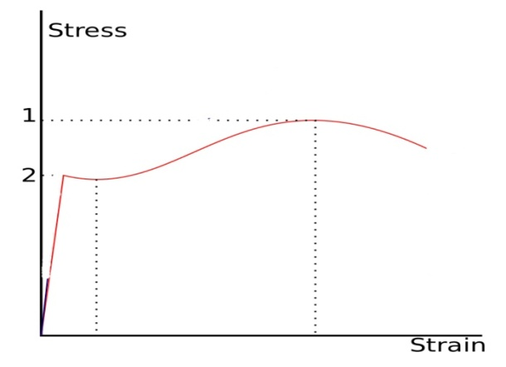

**Fig.** A stress-strain curve. **1**. Ultimate Strength **2**. [Yield Strength](http://en.wikipedia.org/wiki/Yield_Strength)

***Elasticity:*** When an external stress is applied to a solid body, the body tends to pull itself apart. This causes the distance between atoms in the lattice to increase. Each atom tries to pull its neighbor as close as possible. This causes a force trying to resist the deformation. This force is known as strain. If a graph of stress versus strain is plotted, the plot will be a linear one for some lower values of strain. This linear area is the zone which the object is deformed elastically. The elastic deformation of a solid is a reversible process, when the applied stress is removed the solid returns to its original state.

***Plasticity:*** When the plot of stress versus strain is linear, the system is said to be in the elastic state. However, when the stress is high the plot passes a small jump on the axes. This limit is when it becomes a plastic deformation. This limit is known as the *yield strength* of the material. The plastic deformation is sometimes known as the irreversible deformation. After the yield strength jump, the stress versus strain plot becomes a smooth curve with a peak. The peak of this curve is known as the *ultimate strength*. Plastic deformation is used in metal hardening to pack the atoms thoroughly.

***What is the difference between Plasticity and Elasticity?***

• Plasticity is the property that causes irreversible deformations on an object or a system. Such deformations can be caused by forces and impact.

• Elasticity is a property of objects or systems that allows them to deform reversibly. Elastic deformations can be caused by forces and impacts.

•An object must pass the elastic deformation stage in order to enter the plastic deformation stage.